# Heap Organized Tables

## Task 1 – Heap Understanding

**Task Results:**

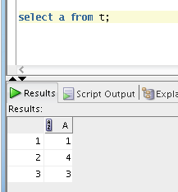

## Task 2 – Understanding Low level of data abstraction: Heap Table Segments

**Task Results:**

Step 1: Table Created;

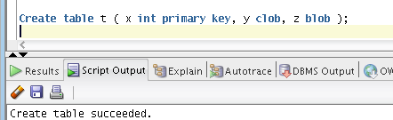

Step 2: Empty selection

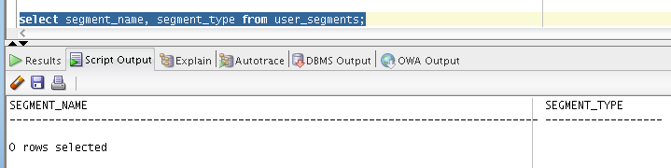

Step 3: Table Created (1 Tip);

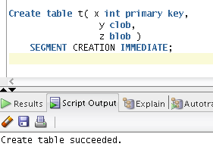

**Step 4**: Expected Result:

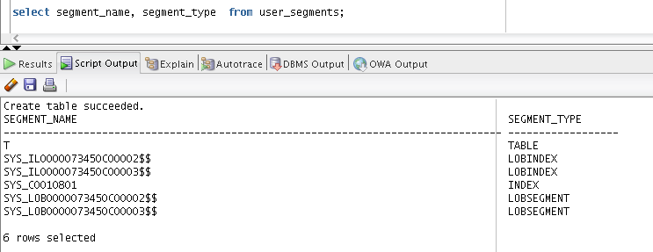

Metadata

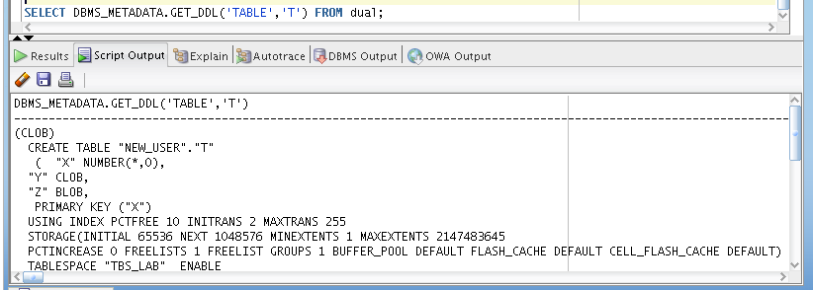

# Index Organized Tables

## Task 3: Compare performance of using IOT tables

**Task Results:**

Step 1-3: Tables Created;

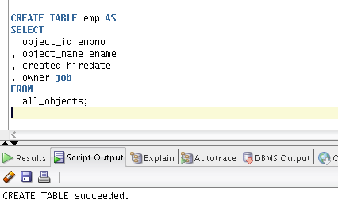

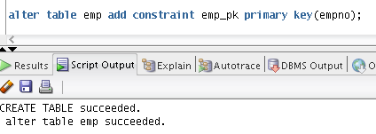

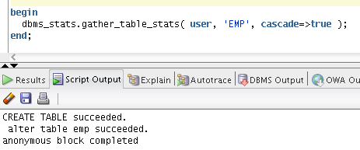

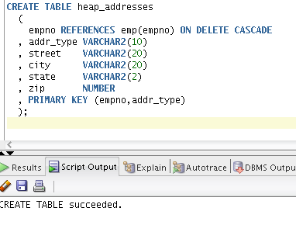

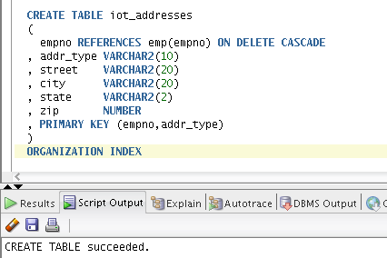

Step 4: Inserting rows;

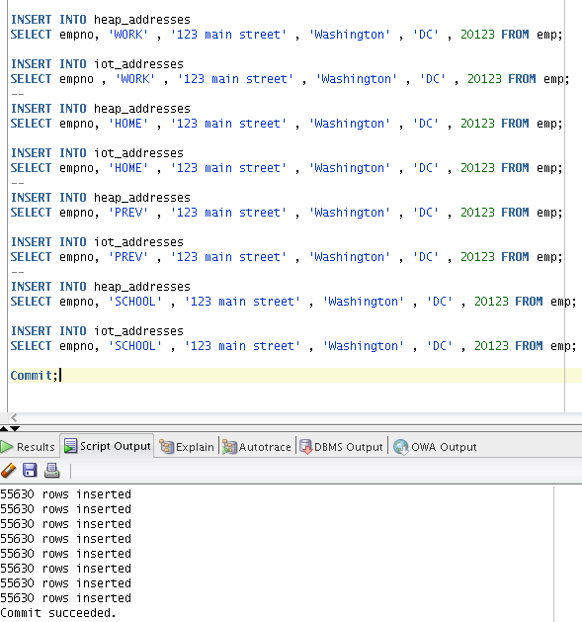

Step 5: Calculate statistic;

**Step 6: Compare**

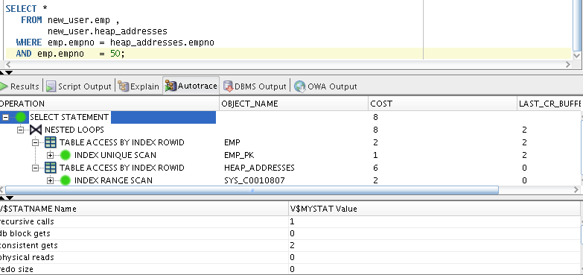

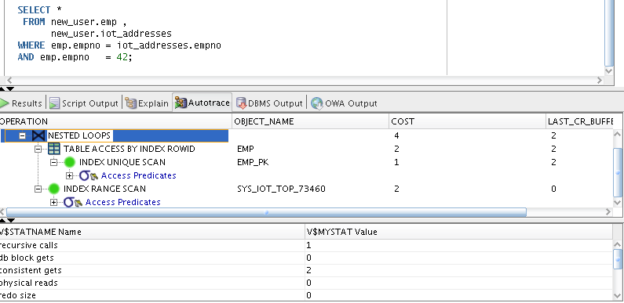

Expected Heap table cost > IOT table cost

Prepare screenshots and write explanation why cost is different.

Heap table cost > IOT cost as expected. Request to emp table has same cost. We join our tables on empno column. So in second case we don’t need access iot_addresses, cause we can get our data which stored by index value.( it’s about place their storage - main feature of index organized tables ).

Step 7: clean up scheme;

drop table emp cascade constraints;

# Index Clustered Tables

## Task 4: Analyses Cluster Storage by Blocks

Step 1: Cluster Created and Index Created;

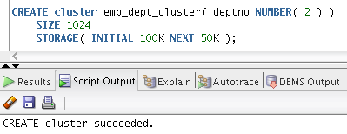

Step 2:

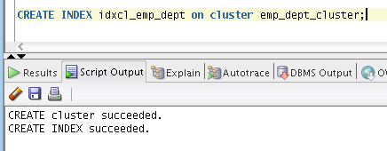

Step 3: Table Created and Initialize Inserting rows Finished;

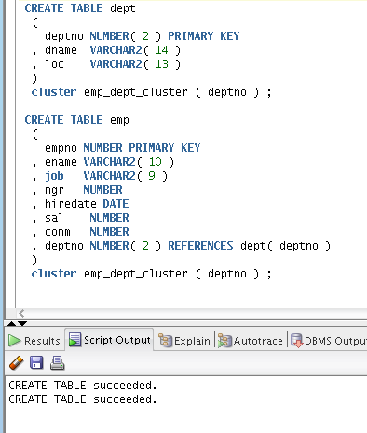

Step 4:

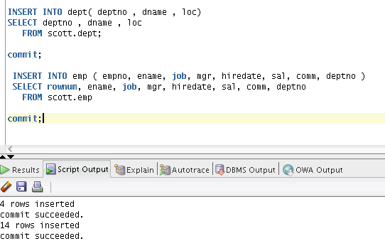

**Step 5:** Expected All data have to be stored on the same block.

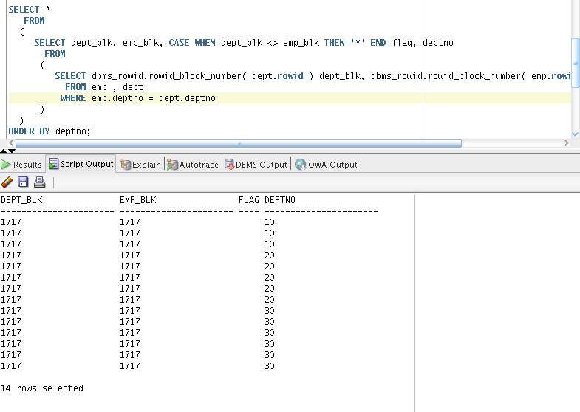

.

Clusters are groups of one or more tables, physically stored on the same database blocks, with all rows that share a common cluster key value being stored physically near each other © .  
Seems it explains everything.

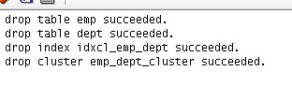

# Hash Clustered Tables

## Task 5: Analyses Cluster Storage by Blocks

Make the same steps as on task 4.1 with one difference create Hash Cluster.

1. Create hash cluster(hashkey is a bit random )

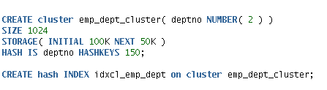

Other steps same to previous task. Except of the index creation(don’t create).

1. Select values from hash cluster.

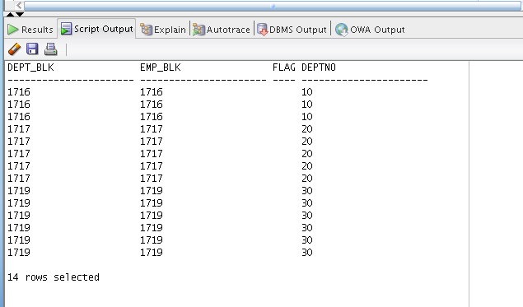

Values in hash cluster stored together, by the value of cluster field(deptno). It means rows stored in the same blocks where value of deptno is the same. (10-1716,20-1717..e.t.c.).